Hydrates are ionic salts that have a definite amount of water molecules bonded to that ionic compound.
The formula of a hydrate is represented in a special way: ionic salt • x (H₂O) The x represents a specific number of water molecules.

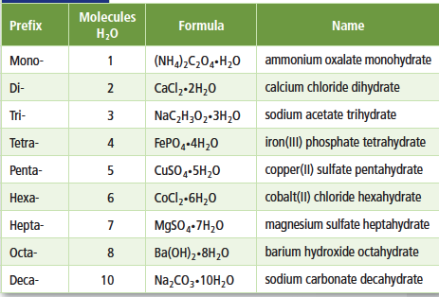
IMPORTANT
To separate a hydrate from a water molecule you have to heat it! The hydrate separates into water and into an anhydrous salt. When you heat a hydrate and start to evaporate out the water, the color changes and the mass will also change due to the loss of water.
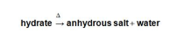
Anhydrous = desiccated-it has no more water in it. It’s just the ionic salt
Hydrate= salt with the water molecules still bonded.

% water = $\frac{mass of water}{mass of hydrate}$ x 100

Calculate the % composition of water in BaCl_{2 •} 2H₂O

You can also calculate the % water during a laboratory. If you have the mass of the hydrate before and then the mass of the hydrate after it has been heated, you can calculate the % composition of water.
SIMPLE VERSION
A 4.5 g sample of a hydrate Ca(NO₃)₂ • x(H₂O) was heated and after it was heated, 2.8 g of the anhydrous salt remained. What percentage of water was in the hydrate?

How do you find the formula of a hydrate if you do not know the specific quantity of water molecules?
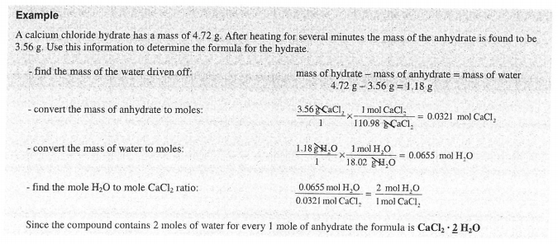
==============================================================================

- A hydrate of magnesium sulfate has a mass of 13.52 g. This sample is heated until no water remains. The MgSO₄ anhydrate has a mass of 6.60 g. Find the formula and name of the hydrate.

- A sample of copper (II) sulfate hydrate has a mass of 3.97 g. After heating, the CuSO₄ that remains has a mass of 2.54 g. Determine the correct formula and name of the hydrate.

- When 5.00 g of FeCl₃ · xH₂0 are heated, 2.00 g of H₂O are driven off. Find the chemical formula and the name of the hydrate.

- A sample of the hydrate of sodium carbonate has a mass of 8.85 g. It loses 1.28 g when heated. Find the formula and the name of the hydrate.

